­Name: ______________________________________________________



Bootstrap:2



­

Class: ______________________________________________________

# Lesson 1

|  |  |  |
| --- | --- | --- |
|  | **Racket Code** | **Pyret Code** |
| ***Numbers*** | (define AGE 14)  (define A-NUMBER 0.6)  (define SPEED -90) | AGE = 14  A-NUMBER = 0.6  SPEED = -90  Two of your own:  **MY-NUMBER = 75.9**  **THREE = 3** |
| ***Strings*** | (define CLASS “Bootstrap”)  (define PHRASE "Coding is fun!")  (define A-STRING "2500") | CLASS = “Bootstrap”  PHRASE = “Coding is fun!”  A-STRING = “2500”  Two of your own:  **MY-NAME = “Elizabeth”**  **MY-NUMBER = 75.9** |
| ***Images*** | (define SHAPE  (triangle 40 "outline" "red"))  (define OUTLINE  (star 80 "solid" "green"))  (define SQUARE   (rectangle 50 50 "solid" "blue")) | SHAPE =  triangle(40, "outline", "red")  OUTLINE =  star(80, “solid”, “green”)  SQUARE =  rectangle(50, 50, “solid”, “blue”)  One of your own:  **MY-SHAPE = rhombus(90, 60, “solid”, “red”)** |
| ***Booleans*** | (define BOOL true)  (define BOOL2 false) | BOOL = true  One of your own:  **BOOL2 = false** |
| ***Functions*** | ; double : Number -> Number  ; Given a number, multiply by  ; 2 to double it  (EXAMPLE (double 5) (* 2 5)  (EXAMPLE (double 7) (* 2 7))  (define (double n) (* 2 n)) | # double : Number -> Number  # Given a number, multiply by  # 2 to double it  examples:  double(5) is 2 * 5  double(7) is 2 * 7  end  fun double(n):  2 * n  end |

## Fast Functions!

Fill out the contract for each function, then try to write two examples and the definition by yourself.

**n**

**n**

**n**

**n**

**n**

**n**

**n**

**n**

3 * n

3 * 8

3 * 16

n

8

16

triple

triple

triple

triple

Number

Number

|  |
| --- |
| # _________________:_________________ -> ________________  double  Number  Number  name domain range |
| examples:  ___________(________) is ______________________________  2 * 5  5 |
| ___________(________) is _______________________________  2 * 7  7  double  double  end  fun ____________(_________________): |
| 2 * n  n  double  ______________________________________________________  end |
| # _________________:_________________ -> ________________  name domain range |
| examples:  ___________(________) is ______________________________ |
| ___________(________) is _______________________________  end  fun ____________(_________________): |
| _______________________________________________________  end |

## Fast Functions!

Fill out the contract for each function, then try to write two examples and the definition by yourself.

**n**

**n**

**n**

**n**

n

55

6

plus1

n + 1

55 + 1

6 + 1

Number

Number

plus1

plus1

plus1

**n**

**n**

**n**

**n**

n

75 - 4

30

75

mystery

Number

Number

mystery

mystery

30 - 4

mystery

n - 4

|  |  |
| --- | --- |
| # _________________:_________________ -> ________________  name domain range | |
| examples:  ___________(________) is ______________________________ |
| ___________(________) is _______________________________  end  fun ____________(_________________): |
| ______________________________________________________  end |
| # _________________:_________________ -> ________________  name domain range | |
| examples:  ___________(________) is ______________________________ |
| ___________(________) is _______________________________  end  fun ____________(_________________): |
| _______________________________________________________  end |

## Fast Functions!

Fill out the contract for each function, then try to write two examples and the definition by yourself.

**radius**

**radius**

**radius**

**radius**

circle(radius, “solid”, “red”)

circle(99, “solid”, “red”)

circle(20, “solid”, “red”)

20

99

Number

Image

red-spot

red-spot

red-spot

radius

red-spot

|  |  |
| --- | --- |
| # _________________:_________________ -> ________________  name domain range | |
| examples:  ___________(________) is ______________________________ |
| ___________(________) is _______________________________  end  fun ____________(_________________): |
| ______________________________________________________  end |
| # _________________:_________________ -> ________________  name domain range | |
| examples:  ___________(________) is ______________________________ |
| ___________(________) is _______________________________  end  fun ____________(_________________): |
| _______________________________________________________  end |

# Bug Hunting: Pyret Edition

|  |  |  |
| --- | --- | --- |
| ***#1*** | SECONDS = (7)  STRING = my string | **SECONDS = 7**  **STRING = “my string”** |
| ***#2*** | SHAPE1 = circle(50 “solid” “blue”)  SHAPE2 = triangle(75, outline, yellow) | **SHAPE1 = circle(50, “solid”, “blue”)**  **SHAPE2 = triangle(75, “outline”, “yellow”)** |
| ***#3*** | # triple : Number -> Number  # Multiply a given number by  # 3 to triple it  examples:  triple(5) = 3 * 5  triple(7) = 3 * 7  end | **# triple : Number -> Number**  **# Multiply a given number by 3 to triple it**  **examples:**  **triple(5) is 3 * 5**  **triple(7) is 3 * 7**  **end** |
| ***#4*** | fun triple(n):  3 * n | **fun triple(n) :**  **3 * n**  **end** |
| ***#5*** | # ys : Number -> Number  # Given a number, create a solid  # yellow star of the given size  examples:  ys(99) is star(99, “solid”, “yellow”)  ys(33) is star(99, “solid”, “yellow”)  ys(size):  star(size “solid” “yellow”)  end | **# ys : Number -> Number**  **# Given a number, create a solid yellow star of the given size**  **examples:**  **ys(99) is star(99, “solid”, “yellow”)**  **ys(99) is star(99, “solid”, “yellow”)**  **end**  **ys(size) :**  **star(size, “solid”, “yellow”)**  **end** |

# Lesson 2

# Word Problem: double-radius

Write a function *double-radius*, which takes in a radius and a color. It produces an outlined circle of whatever color was passed in, whose radius is twice as big as the input.

## Contract+Purpose Statement

Every contract has three parts:

Image

Number, String

double-radius

# _______________ : ____________________________________ -> ____________

name Domain Range

Consumes a number and a string, produces an outlined circle of the given color, whose radius is twice the given number

# ________________________________________________________________________

What does the function do?

# Give Examples

Write examples of your function in action

**radius**

examples:

**color**

50, “pink”

double-radius

_____________(___________________) is

the user types…

**radius**

**color**

circle(50 * 2, “outline”, “pink”)

________________________________________________________________

...which should become

**color**

**radius**

double-radius

918, “orange”

_____________(___________________) is

the user types…

**color**

**radius**

circle(918 * 2, “outline”, “orange”)

________________________________________________________________

...which should become

end

# Function

Circle the changes in the examples, and name the variables.

Write the code, copying everything that isn't circled, and using names where you find variables!

double-radius

radius, color

fun ___________________(__________________) :

circle(radius * 2, “outline”, color)

______________________________________________________________

end

# Word Problem: double-width

Write a function *double-width*, which takes in a number (the length of a rectangle) and produces a solid green rectangle whose width is twice the given length.

## Contract+Purpose Statement

Every contract has three parts:

Image

Number

double-width

# _______________ : ____________________________________ -> ____________

name Domain Range

Consumes a length and produces a solid green rectangle whose width is twice the given length

# ________________________________________________________________________

What does the function do?

# Give Examples

Write examples of your function in action

examples:

**length**

45

double-width

_____________(___________________) is

the user types…

**length**

**length**

rectangle(45, 45 * 2, “solid”, “green”)

________________________________________________________________

...which should become

**length**

8

double-width

_____________(___________________) is

the user types…

**length**

**length**

rectangle(8, 8 * 2, “solid”, “green”)

________________________________________________________________

...which should become

end

# Function

Circle the changes in the examples, and name the variables.

Write the code, copying everything that isn't circled, and using names where you find variables!

length

double-width

fun ___________________(__________________) :

rectangle(length, length * 2, “solid”, “green”)

______________________________________________________________

end

# Word Problem: next-position

Write a function *next-position*, which takes in two numbers (an x and y-coordinate) and returns a Coord, increasing the x-coordinate by 5 and decreasing the y-coordinate by 5.

## Contract+Purpose Statement

Every contract has three parts:

Coord

Number, Number

next-position

# _______________ : ____________________________________ -> ____________

name Domain Range

Given 2 numbers, make a Coord by adding 5 to x and subtracting 5 from y

# ________________________________________________________________________

What does the function do?

# Give Examples

Write examples of your function in action

examples:

**x**

**y**

30, 250

next-position

_____________(___________________) is

the user types…

**y**

**x**

coord(30 + 5, 250 – 5)

________________________________________________________________

...which should become

**y**

**x**

65, 800

next-position

_____________(___________________) is

the user types…

**y**

**x**

coord(65 + 5, 800 – 5)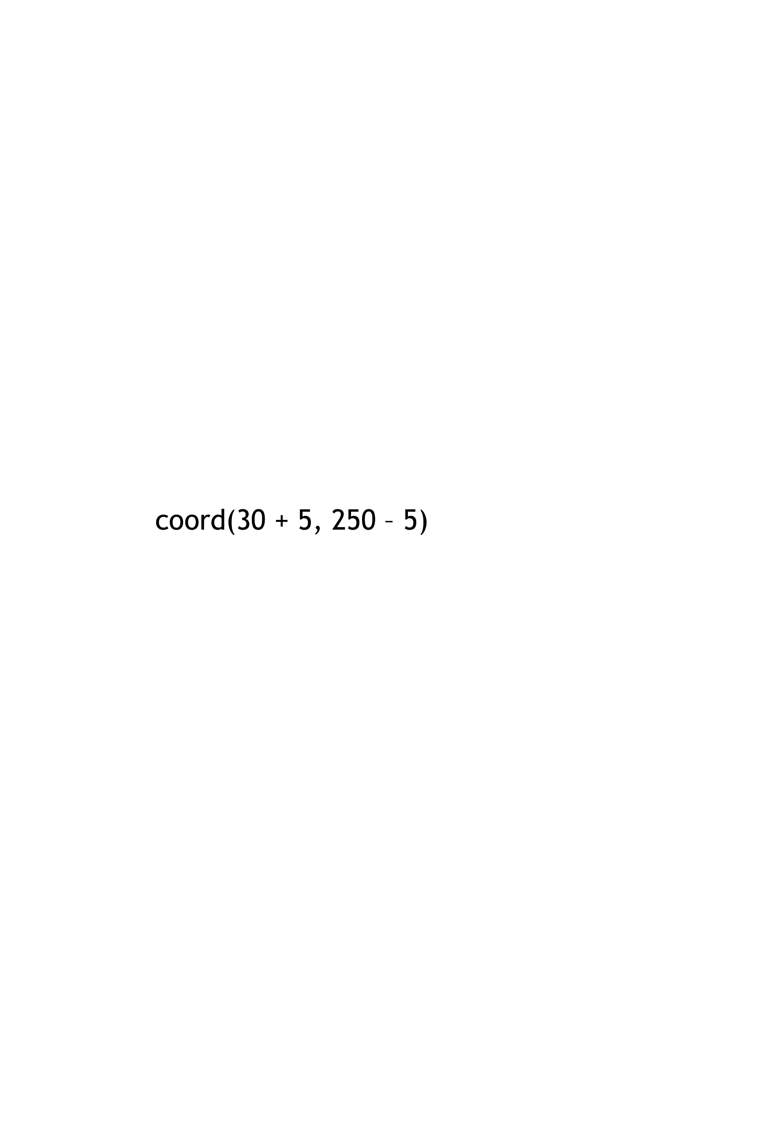 – 5)

________________________________________________________________

...which should become

end

# Function

Circle the changes in the examples, and name the variables.

Write the code, copying everything that isn't circled, and using names where you find variables!

x , y

next-position

fun ___________________(__________________) :

coord(x + 5, y – 5) – 5)

______________________________________________________________

end

# Data Structure

# a Cake is a **flavor, color, message, layers, & is-iceCream**

data **Cake**:

flavor :: String,

| **cake**(______________________________________________

color :: String,

______________________________________________

message :: String,

______________________________________________

layers :: Number,

______________________________________________

is-iceCream :: Boolean

______________________________________________)

end

To make examples of this structure, I would write:

cake(“Vanilla”, “white”, “Happy wedding!”, 4, false)

**cake1** = ____________________________________________

cake(“Red Velvet”, “darkred”, “I love cakes!”, 2, true)

**cake2** = ____________________________________________

To access the fields of **cake2**, I would write:

cake2.flavor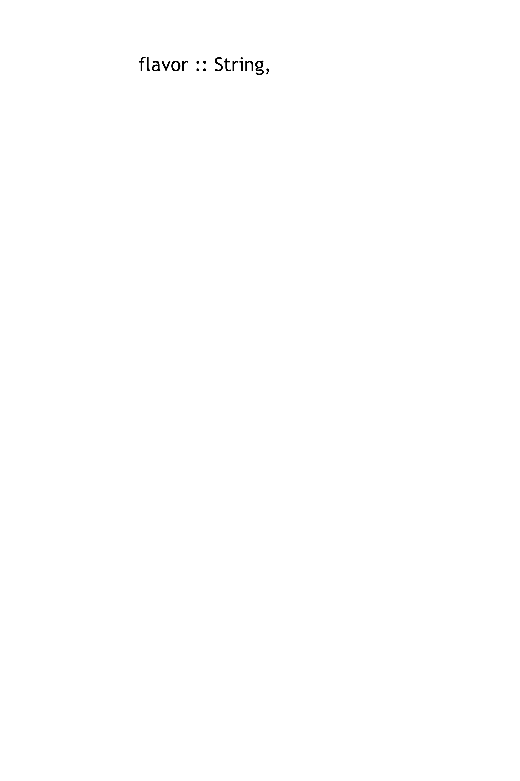r

_______________________________________

cake2.colorr

_______________________________________

cake2.messager

_______________________________________

cake2.layersr

_______________________________________

cake2.is-iceCreamr

_______________________________________

# Lesson 3

# Data Structure

# a Party is a **location, theme, and number of guests**

data **Party**:

location :: String,

| **party**(___________________________________________

theme :: String,

___________________________________________

guests :: Number

___________________________________________)

end

To make examples of this structure, I would write:

party(“Downtown”, “80s”, 34)

**party1** = ____________________________________________

party(“bowling ally”, “bowling”, 20)

**party2** = ____________________________________________

To access the fields of **party2**, I would write:

party2.location

_______________________________________

party2.theme

_______________________________________

party2.guests

_______________________________________

# Word Problem: change-flavor

Write a function called *change-flavor,* which takes in a Cake and a flavor, and returns a new Cake that is almost the same as the original, but is now the given flavor.

# Contract+Purpose Statement

Cake, String

Cake

change-flavor

# __________________ : _________________________________ -> ____________

Given a Cake and a flavor, return a new Cake that is the same as the original, but with the given flavor

# ________________________________________________________________________

# Give Examples

examples:

**new-flavor**

**a-cake**

change-flavor

cake1, “strawberry”

_____________(___________________) is

cake(“strawberry”,

cake1.color,

cake1.message,

cake1.layers,

cake1.is-iceCream)

**new-flavor**

___________________________________________

**a-cake**

___________________________________________

**a-cake**

___________________________________________

**a-cake**

___________________________________________

**a-cake**

___________________________________________

**new-flavor**

**a-cake**

cake2, “vanilla”

change-flavor

_____________(___________________) is

**new-flavor**

cake(“vanilla”,

cake2.color,

cake2.message,

cake2.layers,

cake2.is-iceCream)

___________________________________________

**a-cake**

___________________________________________

**a-cake**

___________________________________________

**a-cake**

___________________________________________

**a-cake**

___________________________________________

end

# Function

a-cake, new-flavor

change-flavor

fun ___________________(__________________) :

cake(new-flavor,

a-cake.color,

a-cake.message,

a-cake.layers,

a-cake.is-iceCream)

___________________________________________

___________________________________________

___________________________________________

___________________________________________

___________________________________________

end

# Word Problem: will-melt

Write a function called *will-melt,* which takes in a Cake and a temperature, and returns true if the temperature is greater than 32 degrees, AND the Cake is an ice cream cake.

# Contract+Purpose Statement

Cake, Number

Boolean

will-melt

# __________________ : _________________________________ -> ____________

Given a Cake and a temperature, return true if the temp is greater than 32 degrees, AND the Cake is an ice cream cake

# ________________________________________________________________________

# Give Examples

examples:

**temp**

**a-cake**

will-melt

cake3, 75

_____________(___________________) is

______________________________________________________________

**temp**

**temp**

**a-cake**

**a-cake**

cake3.is-iceCream and (75 > 32)

cake4, 10

will-melt

_____________(___________________) is

______________________________________________________________

**temp**

**a-cake**

cake4.is-iceCream and (10 > 32)

end

# Function

a-cake, temp

will-melt

fun ___________________(__________________) :

______________________________________________________________

a-cake.is-iceCream and (temp > 32)

end

# Lesson 4

# Lesson 5

# Word Problem: keypress (Ninja World)

# State the Problem

For each keypress in Ninja World, show how (keypress <world > <key>) should change the world.

# Contract+Purpose Statement

# keypress : World, String -> World

# Given a world and a key, produce a new world with NinjaCat’s position

# moved by 10 pixels, depending on which arrow key was pressed

# Give Examples

examples:

**key**

**current-world**

**direction**

keypress(worldA, “up”) is

world(worldA.dogX, worldA.coinX, worldA.catX, worldA.catY + 10)

**key**

**current-world**

keypress(worldB, “down”) is

**direction**

world(worldB.dogX, worldB.coinX, worldB.catX, worldB.catY - 10)

**key**

**current-world**

keypress(worldA, “left”) is

**direction**

world(worldA.dogX, worldA.coinX, worldA.catX - 10, worldA.catY)

**key**

**current-world**

keypress(worldB, “right”) is

**direction**

world(worldB.dogX, worldB.coinX, worldB.catX + 10, worldB.catY)

end

# Function

fun keypress(current-world, key) :

ask:

| string-equal(key, “up”) then:

world(current-world.dogX, current-world.coinX,

current-world.catX, current-world.catY + 10)

| string-equal(key, “down”) then:

world(current-world.dogX, current-world.coinX,

current-world.catX, current-world.catY - 10)

| string-equal(key, “left”) then:

world(current-world.dogX, current-world.coinX,

current-world.catX - 10, current-world.catY)

| string-equal(key, “right”) then:

world(current-world.dogX, current-world.coinX,

current-world.catX + 10, current-world.catY)

| otherwise: current-world

end

end

# Word Problem: next-world (Ninja World)

Given a world, return the next world by adding 10 to dogX, subtracting 5 from coinX, and subtracting 5 from catY *only* when the cat’s y-coordinate is greater than 75.

# Contract+Purpose Statement

World

next-world

# __________________ : _________________________________ -> ____________

Given a World, check whether CatY is greater than 75. If so, create a world by adding 10 to dogX and subtracting 5 from coinX and catY. Otherwise, create a world whose catY is the same as the current world, with dogX and coinX changing as above

World

# ________________________________________________________________________

# Give Examples

examples:

**current-world**

worldA

next-world

_____________(___________________) is

**current-world**

**falling-speed**

world(worldA.dogX + 10, worldA.coinX – 5, worldA.catX, worldA.catY – 5)

_______________________________________________________________________________

**current-world**

next-world

worldB

_____________(___________________) is

**current-world**

_______________________________________________________________________________

world(worldB.dogX + 10, worldB.coinX – 5, worldB.catX, worldB.catY)

end

# Function

current-world

next-world

fun ___________________(__________________) :

ask:

current-world.catY > 75

| ___________________________________________ then:

world(current-world.dogX + 10,

current-world.coinX – 5,

___________________________________________________________________

___________________________________________________________________

current-world.catX,

current-world.catY - 5)

___________________________________________________________________

___________________________________________________________________

| otherwise:

world(current-world.dogX + 10,

current-world.coinX – 5,

__________________________________________________________________

___________________________________________________________________

current-world.catX,

current-world.catY)

___________________________________________________________________

___________________________________________________________________

end

­end

# Lesson 6

# Word Problem: red-shape

Write a function *red-shape*, which takes in the name of a shape (such as “circle”, “triangle”, “star”, or “rectangle”), and draws that solid, red shape. Use 50 as the radius of the circle and star, and side-length of the triangle. Make the rectangle 99 pixels long by 9 wide.

String

Image

# : ->

Consumes the name of a shape, and produces a solid, red image of that shape. Use 50 for size of the circle, star, and triangle, and make the rectangle 99 x 9

red-shape

#

# Give Examples

**size**

**shape-name**

examples:

**shape**

circle( 50, “solid”, “red”)

“circle”

red-shape

_____________(_______________) is _________________________________

**size**

**shape-name**

**shape**

triangle( 50, “solid”, “red”)

“triangle”

red-shape

_____________(_______________) is _________________________________

**size**

**shape-name**

**shape**

star( 50, “solid”, “red”)

“star”

red-shape

_____________(_______________) is _________________________________

**size**

**shape-name**

**shape**

rectangle( 99, 9, “solid”, “red”)

“rectangle”

red-shape

_____________(_______________) is _________________________________

end

# Function

shape

red-shape

fun _______________(_____________________) :

ask:

string-equal(shape, “circle”)

| ________________________________________ then:

circle( 50, “solid”, “red”)

_______________________________________________________

string-equal(shape, “triangle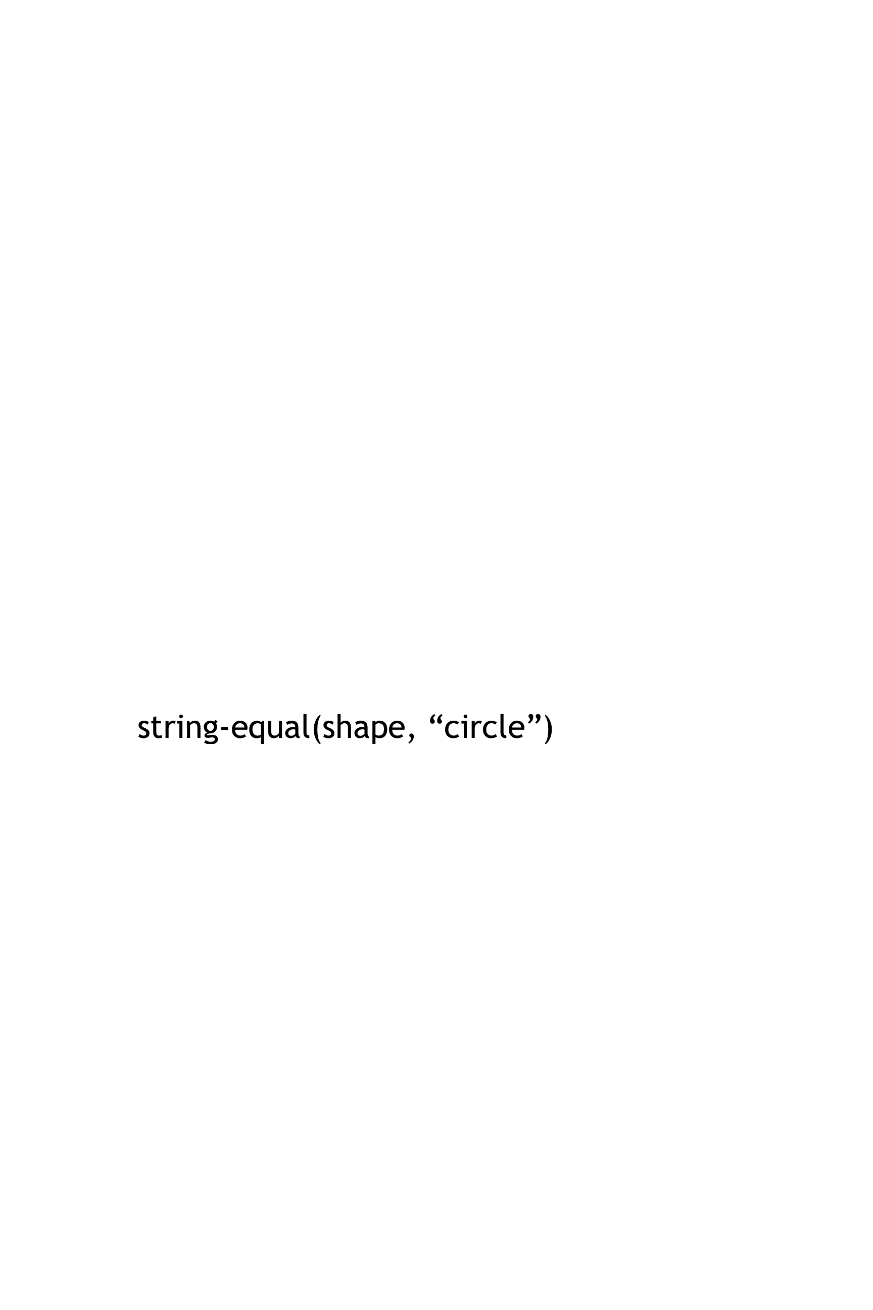”)

| ________________________________________ then:

triangle( 50, “solid”, “red”)

_______________________________________________________

string-equal(shape, “star”)

| ________________________________________ then:

star( 50, “solid”, “red”)

_______________________________________________________

string-equal(shape, “rectangle”)

| ________________________________________ then:

rectangle( 99, 9, “solid”, “red”)

_______________________________________________________

end

end

# Word Problem: strong-password

Websites have strict password requirements. Write a function *strong-password*, which takes in a username and password, and checks to make sure they aren’t the same, and then checks the string-length of the password to make sure it is greater than 8 characters. The function should return a message to the user letting them know if their password is strong enough.

strong-password

# : ->

Given a username and password, check whether they are the same, then check whether the string-length of the password is greater than 8

String, String

String

#

# Give Examples

examples:

**password**

**username**

“Coolguy90”, “Coolguy90”

strong-password

_____________________(__________________________) is

**message**

“Your username cannot be the same as your password!”

______________________________________________________

**username**

**password**

“greatname”, “abc”

strong-password

_____________________(__________________________) is

**message**

“Your password is too short! Must be at least 8 characters.”

______________________________________________________

**password**

**username**

“Katie”, “BootstrapPro78”

strong-password

_____________________(__________________________) is

**message**

“Your password is strong enough! Account created.”

______________________________________________________

end

# Function

username, password

strong-password

fun ________________(_____________________) :

ask:

string-equal(username, password)

| __________________________________________________ then:

“Your username cannot be the same as your password!”

_______________________________________________________

string-length(password) < 8

| __________________________________________________ then:

“Your password is too short! Must be at least 8 characters.”

_______________________________________________________

“Your password is strong enough! Account created.”

| otherwise: _____________________________________________

end

end

Building Your Helper Functions

|  |
| --- |
| # is-off-right :____________________ -> ________________  Number  Boolean |
| examples:  **x-coordinate**  ___________________(________) is  **x-coordinate**  320  is-off-right  ______________________________________________  320 > 690 |
| ___________________(________) is  **x-coordinate**  **x-coordinate**  800  is-off-right  ______________________________________________  800 > 690  end  fun ____________(_________________):  x-coordinate  is-off-right |
| x-coordinate > 690  _______________________________________________________  end |
| # is-off-left :_________________ -> ________________  Boolean  Number |
| examples:  **x-coordinate**  ___________________(________) is  **x-coordinate**  77  is-off-left  ______________________________________________  **x-coordinate**  77 < -50 |
| ___________________(________) is  **x-coordinate**  is-off-left  -400  ______________________________________________  -400 < -50  end  fun ____________(_________________):  x-coordinate  is-off-left |
| x-coordinate < -50  _______________________________________________________  end |
| # _________________:_________________ -> _______________  Number  Boolean  is-in-air |
| examples:  **y-coordinate**  ___________________(________) is  **y-coordinate**  102  is-in-air  ______________________________________________  **y-coordinate**  102 > 75 |
| ___________________(________) is  **y-coordinate**  30  is-in-air  ______________________________________________  30 > 75  end  fun ____________(_________________):  y-coordinate  is-in-air |
| y-coordinate > 75  _______________________________________________________  end |
| # _________________:_________________ -> ________________ |
| examples:  ___________________(________) is  ______________________________________________ |
| ___________________(________) is  ______________________________________________  end  fun ____________(_________________): |
| _______________________________________________________  end |

# Lesson 7

# Word Problem: line-length

Write a function called *line-length*, which takes in two numbers and returns the difference between them. It should always subtract the smaller number from the bigger one.

# Contract+Purpose Statement

Number, Number

Number

line-length

# __________________ : ________________________________________ -> ______________

Consumes 2 numbers and produces the difference by subtracting the smaller number from the larger

# _____________________________________________________________________________

# Give Examples

examples:

**b**

**a**

10, 8

line-length

_____________(_____________) is

10 - 8

________________________________________________________________

**order**

**b**

**a**

60, 300

line-length

_____________(_____________) is

300 - 60

________________________________________________________________

**order**

end

# Function Header

a, b

line-length

fun ___________________(__________________) :

function name variable names

ask

______:

| | a > b then: a - b |  |
| --- | --- |
| | otherwise: b - a |  |
|  |  |
|  |  |
|  |  |
|  |  |

end

end

# Distance:

The Player is at **(4, 2)** and the Target is at **(0, 5)**.

Distance takes in the player’s x, player’s y, character’s x and character’s y.

Use the formula below to fill in the EXAMPLE:

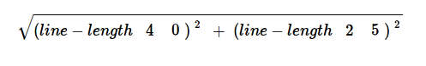

Convert it into a Circle of Evaluation. (We've already gotten you started!)

num-sqrt

+

num-sqr

num-sqr

line-length

line-length

4 0

2 5

Convert it into Pyret code:

num-sqrt(num-sqr(line-length(4, 0)) + num-sqr(line-length(2, 5)))

# Word Problem: distance

*Write a function* distance, *which takes FOUR inputs:*

* *px: The x-coordinate of the player*
* *py: The y-coordinate of the player*
* *cx: The x-coordinate of* another game character
* *cy: The y-coordinate of another game character*

*It should return the distance between the two, using the Distance formula:*

Distance2 = (line-length px cx)2 + (line-length py cy)2 )

# Contract+Purpose Statement

Number, Number, Number, Number

Number

distance

# __________________ : ________________________________________ -> ______________

Given the coordinates of 2 characters: px, py, cx, and cy, use the distance formula to calculate the distance between them

# ______________________________________________________________________________

# Give Examples

Write examples of your function in action

examples:

**cy**

**cx**

**py**

**px**

4, 2, 0, 5

distance

_____________(_____________) is

**cy**

**cx**

**py**

**px**

num-sqrt(num-sqr(line-length(4, 0)) + num-sqr(line-length(2, 5)))

________________________________________________________________

**cy**

**cx**

**py**

**px**

80, 33, 6, 50

distance

_____________(_____________) is

**cy**

**cx**

**py**

**px**

num-sqrt(num-sqr(line-length(80, 6)) + num-sqr(line-length(33, 50)))

________________________________________________________________

end

# Function

distance

px, py, cx, cy

fun ___________________(__________________) :

num-sqrt(num-sqr(line-length(px, cx)) + num-sqr(line-length(py, cy)))

______________________________________________________________

end

# Word Problem: is-collision

Write a function *is-collision*, which takes FOUR inputs:

* px: The x-coordinate of the player
* py: The y-coordinate of the player
* cx: The x-coordinate of another game character
* cy: The y-coordinate of another game character

It should return true if the coordinates of the player are within **50 pixels** of the  
 coordinates of the other character. Otherwise, false.

# Contract+Purpose Statement

Number, Number, Number, Number

Boolean

is-collision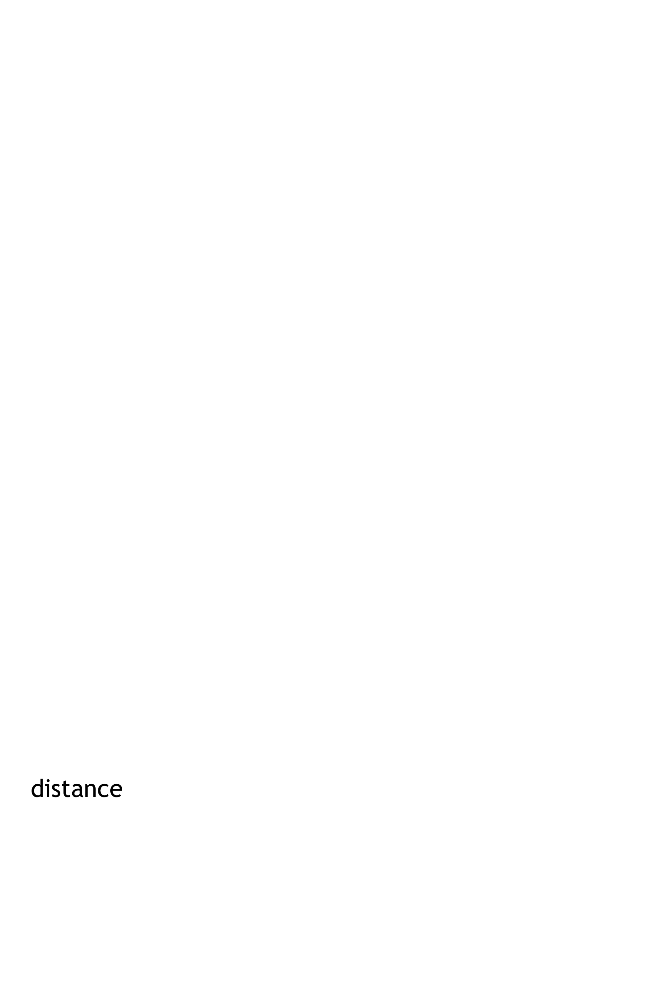

# __________________ : ________________________________________ -> ______________

Given the coordinates of 2 characters: px, py, cx, and cy, return true if the distance between them is less than 50 pixels

# ______________________________________________________________________________

# Give Examples

Write examples of your function in action

examples:

**py**

**cy**

**cx**

**px**

78, 30, 9, 2

is-collision

__________________________ (_____________________) is

distance(78, 30, 9, 2) < 50

________________________________________________________________

**py**

**cy**

**cx**

**px**

20, 40, 60, 80

is-collision

__________________________(_____________________) is

distance(20, 40, 60, 80) < 50

________________________________________________________________

end

# Function

is-collision

px, py, cx, cy

fun ___________________(__________________) :

distance(px, py, cx, cy) < 50

______________________________________________________________

end

# Game Design: SAMPLE

*“Start Simple, Get Complex”*

# Draw a rough sketch of your game when it begins, and another sketch just a moment later

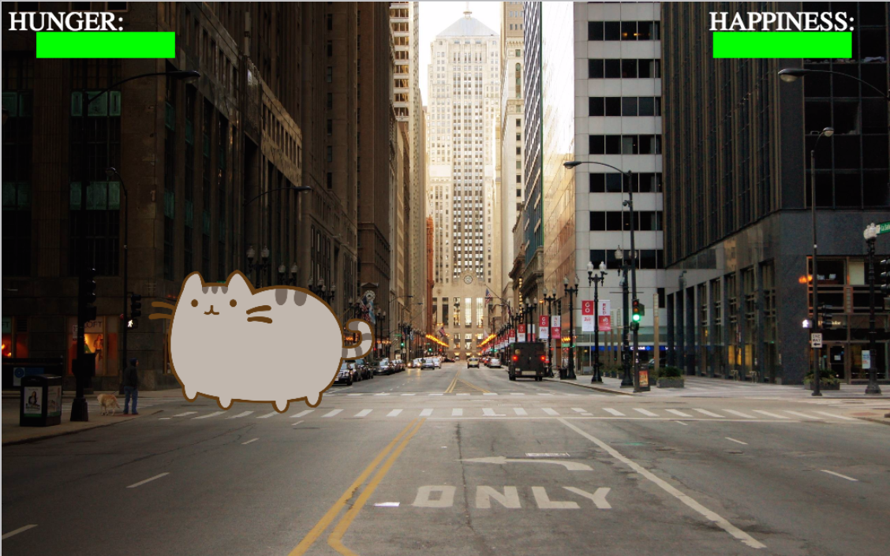 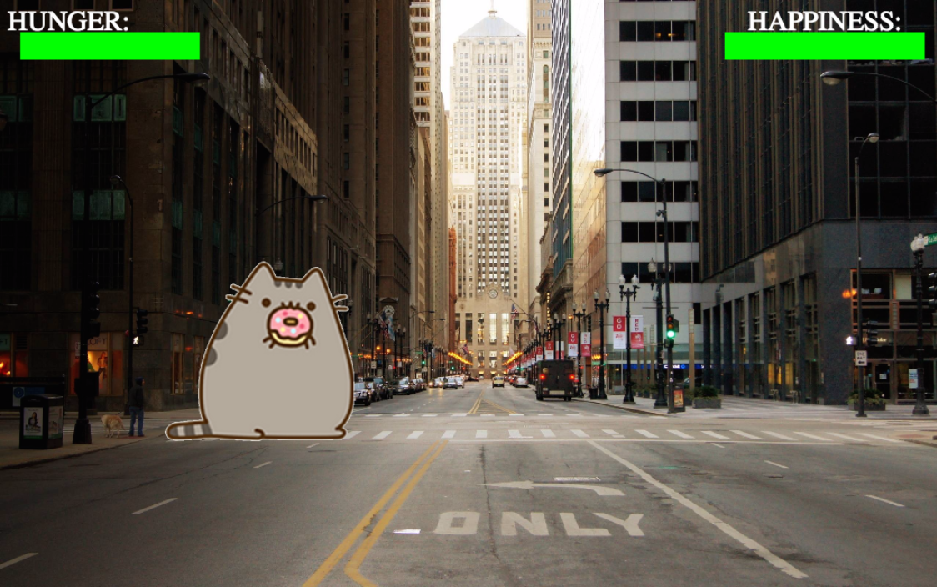

*A sketch for the very NEXT moment…*

*A sketch at the START of the game…*

# What images will you need for your game? Name them in the 1st column, and describe them in the 2 nd

|  |  |
| --- | --- |
| **BACKGROUND** | **CITY STREET** |
| **PET- HAPPY** | **NEUTRAL PET** |
| **PET- EAT** | **EATING PET** |
| **PET- SAD** | **SAD PET** |
| **EMOTION METERS** | **GREEN RECTANGLES** |
|  |  |

# List everything that has changed from one sketch to the other. What datatype will represent it?

|  |  |
| --- | --- |
| **Changed** (position, score, color, costume…) | **Datatype** (Number, String, Image, Boolean…) |
| **COSTUME** | **IMAGE** |
| **HAPPY METER** | **NUMBER** |
| **HUNGER METER** | **NUMBER** |
| **TIMER** | **NUMBER** |
|  |  |
|  |  |
|  |  |
|  |  |
|  |  |

# Data Structures: SAMPLE

# a **world** is a **costume, x-coord, happy, sleep, hunger**

data **World**:

costume :: Image,

| **world**(________________________________

happy :: Number,

________________________________

hunger :: Number,

________________________________

timer :: Number,

________________________________

_________________________________)

end

To make example worlds that represent my sketches from page 31, I would write…

world(NEUTRAL, 12, 12, 7)

**worldA** = ____________________________________________

world(SAD, 3, 10, 10)

**worldB** = ____________________________________________

To access the fields of **worldA**, I would write:

worldA.costume

_______________________________________

worldA.happy

_______________________________________

worldA.hunger

_______________________________________

worldA.timer

_______________________________________

_______________________________________

# Lesson 8

# Word Problem: draw-world (My game)

# Contract

# __________________ : _________________________________________ -> ______________

# Definition

fun ____________(_______________________________) :

put-image(_____________________________________________________

_____________________________________________________

_____________________________________________________

_____________________________________________________

_____________________________________________________

_____________________________________________________

_____________________________________________________

_____________________________________________________

_____________________________________________________

_____________________________________________________

_____________________________________________________

_____________________________________________________

_____________________________________________________

_____________________________________________________

end

# Word Problem: next-world (My game)

# State the problem (What changes?):

# Contract+Purpose Statement

# __________________ : ________________________________________ -> ______________

# ______________________________________________________________________________

# Give Examples

examples:

_____________(___________________) is

___________________________________________

___________________________________________

___________________________________________

___________________________________________

___________________________________________

_____________(___________________) is

___________________________________________

___________________________________________

___________________________________________

___________________________________________

___________________________________________

end

# Function

fun ___________________(__________________) :

___________________________________________

___________________________________________

___________________________________________

___________________________________________

___________________________________________

end

# Lesson 9

|  |  |  |
| --- | --- | --- |
| **When *this* key is pressed…** | ***..this* field of the new world...** | **…changes by…** |
|  |  |  |
|  |  |  |
|  |  |  |
|  |  |  |
|  |  |  |
|  |  |  |

# Word Problem: keypress (My game)

For each keypress in your game, show how keypress(worldA, <key>) should change your world.

# : ->

#

# Give Examples

examples:

keypress(worldA, _________) is

___________________________________________

___________________________________________

___________________________________________

___________________________________________

___________________________________________

keypress(worldA, _________) is

___________________________________________

___________________________________________

___________________________________________

___________________________________________

___________________________________________

keypress(worldA, _________) is

___________________________________________

___________________________________________

___________________________________________

___________________________________________

___________________________________________

end

# Function

fun _____________(________________________________)

ask:

| _____________________________________ then:

_____________________________________________

| _______________________________________ then:

_____________________________________________

| _______________________________________ then:

_____________________________________________

| _______________________________________ then:

_____________________________________________

| _______________________________________ then:

_____________________________________________

| _______________________________________ then:

_____________________________________________

| ______________________________________________

end

end

Building Your Helper Functions

|  |
| --- |
| # is-off-right :____________________ -> ________________ |
| examples:  ___________________(________) is  ______________________________________________ |
| ___________________(________) is  ______________________________________________  end  fun ____________(_________________): |
| _______________________________________________________  end |
| # is-off-left :_________________ -> ________________ |
| examples:  ___________________(________) is  ______________________________________________ |
| ___________________(________) is  ______________________________________________  end  fun ____________(_________________): |
| _______________________________________________________  end |
| # _________________:_________________ -> _______________ |
| examples:  ___________________(________) is  ______________________________________________ |
| ___________________(________) is  ______________________________________________  end  fun ____________(_________________): |
| _______________________________________________________  end |
| # _________________:_________________ -> ________________ |
| examples:  ___________________(________) is  ______________________________________________ |
| ___________________(________) is  ______________________________________________  end  fun ____________(_________________): |
| _______________________________________________________  end |

# Using Helpers inside next-world:

# How does the World structure change when….?

|  |  |
| --- | --- |
| **TEST** | **RESULT** |
|  | world(______________________________________  ______________________________________  ______________________________________  ______________________________________  ______________________________________) |
|  | world(______________________________________  ______________________________________  ______________________________________  ______________________________________  ______________________________________) |
|  | world(______________________________________  ______________________________________  ______________________________________  ______________________________________  ______________________________________) |
|  | world(______________________________________  ______________________________________  ______________________________________  ______________________________________  ______________________________________) |

|  |  |
| --- | --- |
| **TEST** | **RESULT** |
|  | world(______________________________________  ______________________________________  ______________________________________  ______________________________________  ______________________________________) |
|  | world(______________________________________  ______________________________________  ______________________________________  ______________________________________  ______________________________________) |
|  | world(______________________________________  ______________________________________  ______________________________________  ______________________________________  ______________________________________) |
|  | world(______________________________________  ______________________________________  ______________________________________  ______________________________________  ______________________________________) |

# Using Helpers inside draw-world:

# What changes the *appearance* of your game?

|  |  |
| --- | --- |
| **TEST** | **RESULT** |
|  | put-image(___________________________________  put-image( ______________________________  put-image(_______________________________  put-image(_______________________________  put-image(_______________________________ |
|  | put-image(___________________________________  put-image( ______________________________  put-image(_______________________________  put-image(_______________________________  put-image(_______________________________ |
|  | put-image(___________________________________  put-image( ______________________________  put-image(_______________________________  put-image(_______________________________  put-image(_______________________________ |
|  | put-image(___________________________________  put-image( ______________________________  put-image(_______________________________  put-image(_______________________________  put-image(_______________________________ |

|  |  |
| --- | --- |
| **TEST** | **RESULT** |
|  | put-image(___________________________________  put-image( ______________________________  put-image(_______________________________  put-image(_______________________________  put-image(_______________________________ |
|  | put-image(___________________________________  put-image( ______________________________  put-image(_______________________________  put-image(_______________________________  put-image(_______________________________ |
|  | put-image(___________________________________  put-image( ______________________________  put-image(_______________________________  put-image(_______________________________  put-image(_______________________________ |
|  | put-image(___________________________________  put-image( ______________________________  put-image(_______________________________  put-image(_______________________________  put-image(_______________________________ |

# Lesson 10

# Supplemental

Design Recipe

# Contract+Purpose Statement

Every contract has three parts:

# __________________ : ________________________________________ -> ______________

name Domain Range

# ______________________________________________________________________________

What does the function do?

# Give Examples

Write examples of your function in action

examples:

_____________(_____________) is

the user types…

________________________________________________________________

...which should become

_____________(_____________) is

the user types…

________________________________________________________________

...which should become

end

# Function

Circle the changes in the examples, and name the variables.

fun ___________________(__________________) :

______________________________________________________________

end

Design Recipe

# Contract+Purpose Statement

Every contract has three parts:

# __________________ : ________________________________________ -> ______________

name Domain Range

# ______________________________________________________________________________

What does the function do?

# Give Examples

Write examples of your function in action

examples:

_____________(_____________) is

the user types…

________________________________________________________________

...which should become

_____________(_____________) is

the user types…

________________________________________________________________

...which should become

end

# Function

Circle the changes in the examples, and name the variables.

fun ___________________(__________________) :

______________________________________________________________

end

